29.77: The primary assumption throughout the problem is that the square patch is small enough so that the velocity is constant over its whole areas, that is, 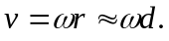
a) 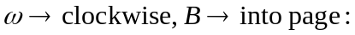
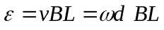
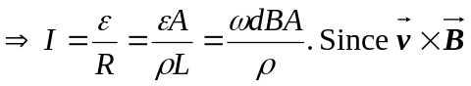 points outward,  is just the cross-sectional
area 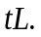
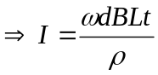 flowing radially outward since 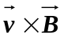 points outward.
b) 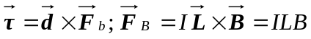 pointing counterclockwise.
So 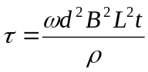 pointing out of the page (a counterclockwise torque opposing the clockwise rotation).
c) If
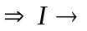flow inward radially since 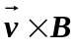 points inward.
clockwise (again opposing the motion);
If counterclockwise and 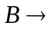 out of the page
radially outward
clockwise (opposing the motion)
The magnitudes of 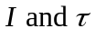 are the same as in part (a).

